Name................................................................................ Telephone number.............................................. Email..................................................................

Address..............................................................

...........................................................................

...........................................................................

Post code...........................................................

Thank you for taking the time to complete this feedback form. Please return it to a member of staff or, if you prefer, send it to:

## Customer Services Department

Livewell Southwest

Crownhill Court

Tailyour Road

Plymouth

PL6 5DH

**Tel:** 01752 435201

**Email:** [customerservicespch@nhs.net](mailto:customerservicespch@nhs.net)

[**www.**livewellsouthwest.co.uk](http://www.livewellsouthwest.co.uk/)

In accordance with the General Data Protection Regulation (GDPR) we will keep the information you provide in a safe place and

will not share this with anyone else, unless you give consent for us to do so.

# Compliments

At Livewell Southwest we encourage people to let us know when they are pleased and satisfied with the services and treatment we provide.

If you wish to send a compliment to any of our staff, wards or services please do so. You can send a card, letter, phone us or fill out the feedback form contained within this leaflet.



This leaflet was updated in February 2023.

Livewell Southwest @livewellsw

What do you think?

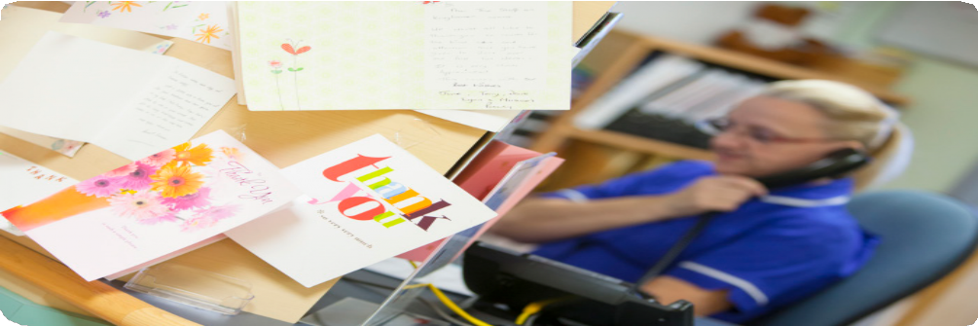

How to make a compliment, raise a concern or complain about our service



Supporting people to lead independent, healthy lives

# Introduction

This leaflet explains how you can make a compliment, raise a concern or make a complaint. We will use your feedback to improve our services.

# Raising a concern

We want everyone to receive the highest level of service. If you feel we have not achieved this, please speak to a member of staff who will try to resolve the matter straight away.

# Making a complaint

If your concern cannot be settled, then you may wish to make a complaint. This should be done as soon as possible but no longer than 12 months after the problem has arisen. In exceptional circumstances complaints can then be made later than this.

When you make your complaint, your information will be treated in confidence and it will not affect your care in any way.

You can make a complaint by completing the feedback form or contacting the Customer Services department using the details on the back of this leaflet.

Someone else can complain on your behalf if you are happy for them to do so. Also, The Advocacy People, an independent advocacy

service, can provide support and guidance for

you:

**Tel:** 0330 440 9000

**Email:** [info@theadvocacypeople.org.uk](mailto:info@theadvocacypeople.org.uk)

**Web:** [www.theadvocacypeople.org.uk](http://www.theadvocacypeople.org.uk/)

# What happens after I’ve complained?

* We will acknowledge your complaint formally within 3 working days and agree with you how long it will take to receive a response
* If you think it would help, we will offer to

meet with you to discuss the complaint

* Your complaint will be investigated and we

will advise you of the outcome

* We will learn from the experience to stop it

from happening again

# Unhappy with our response?

If you remain unhappy with our response you can contact the Parliamentary and Health Ombudsman, or the Local Government Ombudsman.

We will provide contact details of which service you need to contact when you receive your response from us.

# Feedback Form

## Do you want to (tick as appropriate)

Give us a compliment Raise a concern Make a complaint

**Which service?**

..............................................................................

..............................................................................

**Where did you receive the care or service?**

..............................................................................

..............................................................................

**How would you like us to contact you?**

Telephone Email Letter

No response required

**Please provide any brief details**

..............................................................................

..............................................................................

..............................................................................

..............................................................................

..............................................................................

..............................................................................

..............................................................................